Flood Emergency Plan
[Name here]
[Department]
Unit Name:
Instructor:
March 19, 2021

Emergency Plan
The purpose of this plan is to aid my family on how it will respond to floods. The weather forecasts have predicted very high rainfalls in the coming months. This plan clearly outlines actions to be taken in event of a flood event in our home area. Noting that my family lives near major rivers which are likely to burst their banks, extra measures should be taken to avoid being swept away by flowing waters. The actions are proactive in nature to avoid deaths, injuries, and loss of property (McCluskey, M. 2020). Considering my family lives in an area recently prone to seasonal floods, care must be taken to prevent loss. The emergency works to promote stability of the family even in the event of floods.
Person in charge of family emergency plan…………………………
Family emergency response team members…………………………
Before Floods/Preparation
Before the floods, the following activities are undertaken. Older family members are entitled to the welfare of the young ones.
- In case of flood watch or warning, the family members will discuss how to respond to the impending disaster.
- All family members to possess the Safe and Well wallet card (American Red Cross, n.d.).
- The head of the family to acquire the National Oceanic and Atmospheric Administration radio broadcasts (American Red Cross, n.d.).
- Monitor the nearby river water levels and areas likely to spill faster. Ensure the homestead drainage system is not filled with mad.
- Make backups of irreplaceable items like photos and family videos. The soft copy documents will be uploaded to the cloud to be retrieved later. The family vehicles will be filled with fuel before the floods.
- For the current family size of 6, prepare the emergency kit. Ensure all necessities for first aid in place.
- According to American Red Cross (n.d.), all domestic animal feed is to be kept in a dry place and any leaking animal shed repaired. Raise the ground level of areas around the animal shed.
- Raise the home ground or dig tunnels leading floodwater away from home (Russo & Martínez-Gomariz, 2021). The water pipes providing the home with clean and fresh water to be fitted with check valves to prevent backward flow of water. This will ensure that contaminated water does not mix with clean and safe water for domestic use.
- The adult family members to provide labor to fill sandbags and erect walls around areas likely to leak because of floodwaters (American Red Cross, n.d.).
- The family members to be aware of evacuation methods in place and replenish basic human wants like food and water.
- The family homeowner insurance policy will only insure damages to buildings and personal property. The insurance policy also covers family food loss which will result from floods. The family has a deductible of $2,500. This ensures that the risk of damages and losses is shared with the insurance company.
- The head of the emergency plan shall purchase two portable tents to provide shelter if need be during the floods. The tents will have portable chemical toilets.

Response to Floods
Once the onset of floods, the family will stay indoors. The person in charge of the emergency plan will ensure that no less of the following occurs.
- The electricity mains supply is switched off to avoid short-circuiting (American Red Cross, n.d.). Also, water mains are turned off to prevent contamination.
- According to American Red Cross (n.d.), the family shall keep abreast of any updates from National Oceanic and Atmospheric Administration and other media sources.
- Family members are advised not to take anything, food or drink, that has been contaminated with floodwater.
- The children's behavior is monitored to deter them from going outside. Children risk drowning in dangerous holes or slumps. Coming into contact with the flood can also cause water-borne diseases. All adult persons are responsible for children's behavior.
- In case the ground level houses get flooded, go to the upper rooms. No driving through stagnant or moving waters.
- The family will utilize the stored food replenishes to avoid unnecessary inconveniences. There should be enough food and safe water to use for at least 72 hours.
After the Floods
After the floods, safety and precautionary measures to return to the normal way of life.
- Create awareness of the family status to friends and groups and relative (American Red Cross, n.d.). The family members to create an account with the Safe and Well website to enable finding lost friends and relatives.
- If evacuation is done to prevent further injuries don’t return unless advised by relevant authorities. Also if evacuation takes place, the family shall go and stay in a hotel in one of the nearby cities. The family lorry will be used for evacuation and avoid untarmacked routes.
- Continue monitoring children's behavior to deter risky undertakings. Look for updates on weather status and predicted weather patterns on NOAA radio broadcasts, Televisions, and radio stations (American Red Cross, n.d.).
The Emergency Kit/Bug-Out Bag
The family emergency shall hold the essential items necessary for survival for 72 hours. It shall contain;
- Non-perishable food (at least 40kg of staple food)and 18 gallons of safe water for use for 3 days (1 gallon/person per day)
- First aid kit for attending to injuries
- Sleeping blankets, sturdy gloves, and heavy clothes
- Both prescribed and non-prescribed medication and sanitation equipment supplies
- Toys for the small baby and changing clothes
- Three fully-functional waterproof torches, 1 dozen of candles or batteries for lighting purposes since there will be no electricity. The radio for communication purposes will be powered by batteries.
- For family expenses, we will require $1000 for the month. Therefore an equivalent of not less than $5000 in cash will be withdrawn from banks before the onset of floods. It will meet all expenses including evacuation if required.
- The family phones should be fully charged, have phone chargers, emergency call center numbers for Red Cross, and other charity organizations for communication purposes (Peterson, 2019. The emergency number to be used for rescue is 911.
- According to American Red Cross (n.d.), all irreplaceable documents should be backed up and copies kept in the emergency kit. Medical records for all family members, hard drives, and CDs are to be put in the emergency kit.
- A copy of the emergency plan is to be kept in the emergency kit.
- Contact information of renowned masonry, carpenters, and electricians for repair works in the home (Peterson, 2019). Supplies required for repair works include nails (3kg), hammer, saw, cement, and ladder.
- To overcome civil unrest, the family will not be involved in any verbal confrontations whatsoever and should stay calm.
- The frail and elderly will be provided with their necessities by strong and energetic family members at their comfort zones according to their requirements. Our grandfather shall be helped with dressing and his room cleaned regularly.
Bug Out Bag
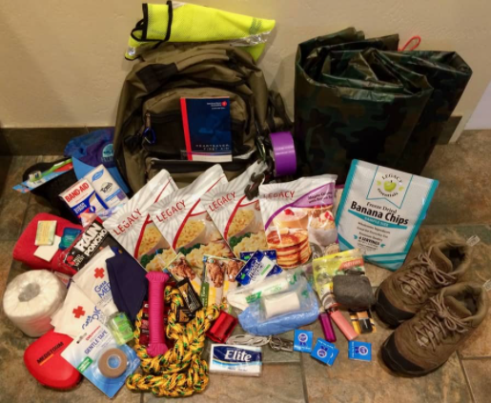

Food Storage
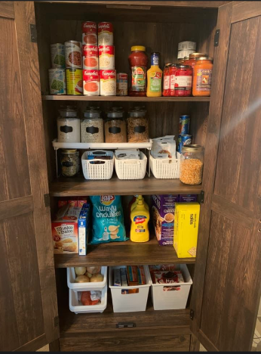
Main House Safety Roadmap
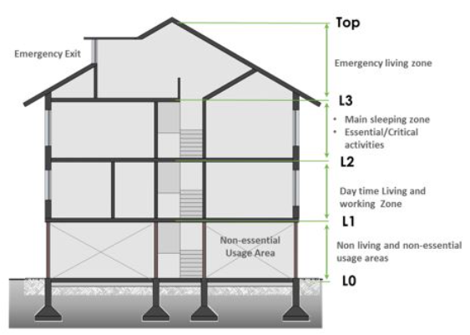

References
American Red Cross. (n.d.). get help. http://www.redcross.org/get-help/how-to-prepare-for-emergencies/types-of-emergencies
McCluskey, M. (2020). News coverage of global disasters: Journalism's power to aid healing and recovery. Lexington Books.
Peterson, J. (2019). A new coast: Strategies for responding to devastating storms and rising seas. Island Press
Russo, B., & Martínez-Gomariz, E. (2021). Integrated assessment of climate change impacts and urban resilience: From climate and hydrological hazards to risk analysis and measures. MDPI.

